**DWBI**

Aim : Implementing cluster based tables in Oracle.

CREATING A USER:

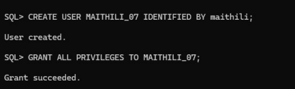Q1. Do as directed:

a. Create a cluster PERSONNEL containing copy_emp and copy_dept tables. Cluster key is deptno.

CREATE CLUSTER personnel (deptno NUMBER(4))

TABLESPACE users

SIZE 512

PCTUSED 80

PCTFREE 5;

1

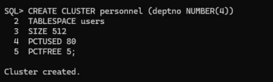CREATE TABLE copy_dept (

deptno NUMBER(4),

dname VARCHAR2(14),

loc VARCHAR2(13)

)

CLUSTER personnel (deptno);

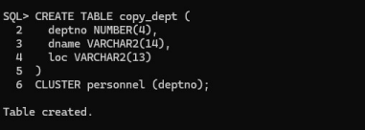CREATE TABLE copy_emp (

empno NUMBER(4),

ename VARCHAR2(10),

job VARCHAR2(9),

mgr NUMBER(4),

hiredate DATE,

sal NUMBER(7, 2),

comm NUMBER(7, 2),

deptno NUMBER(4)

2

)

CLUSTER personnel (deptno);

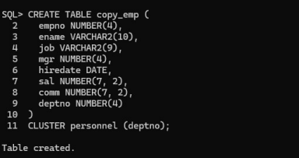

b. create a index on cluster PERSONNEL.

CREATE INDEX idx_personnel_cluster ON CLUSTER personnel;



c. Populate copy_emp and copy_dept with data from emp and dept tables of SCOTT schema, respectively.

INSERT INTO copy_dept (deptno, dname, loc)

SELECT deptno, dname, loc

FROM scott.dept;

3

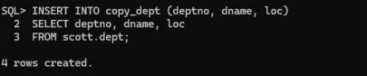INSERT INTO copy_emp (empno, ename, job, mgr, hiredate, sal, comm, deptno) SELECT empno, ename, job, mgr, hiredate, sal, comm, deptno

FROM scott.emp;

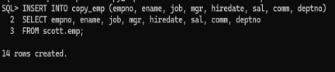

d. Create a dumkmy table &quot;dummy&quot; which references empno of copy_emp.

ALTER TABLE copy_emp ADD CONSTRAINT pk_copy_emp PRIMARY KEY (empno);

CREATE TABLE dummy (

dummy_id NUMBER(4),

empno NUMBER(4),

CONSTRAINT fk_dummy_emp FOREIGN KEY (empno) REFERENCES copy_emp (empno) );

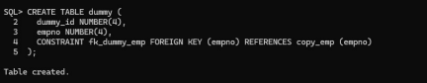4

e. Drop cluster PERSONNEL.

DROP CLUSTER personnel INCLUDING TABLES CASCADE CONSTRAINTS;



f. Create a hash cluster named hash_emp containing table copy101_emp. Create 10 hashkeys and use the hash function (empno mod 100).

CREATE CLUSTER hash_emp (

empno NUMBER(4)

)

HASHKEYS 10;

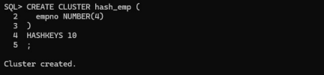

CREATE TABLE copy101_emp (

empno NUMBER(4),

ename VARCHAR2(10),

job VARCHAR2(9),

mgr NUMBER(4),

hiredate DATE,

sal NUMBER(7, 2),

5

comm NUMBER(7, 2),

deptno NUMBER(4)

)

CLUSTER hash_emp (empno);

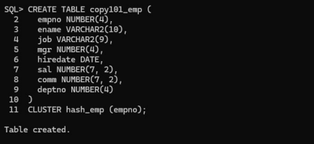Q2. Do as directed:

a. Create a hash cluster named trial_cluster that stores a single table called trial, clustered by the trialno column (the cluster key).

CREATE TABLESPACE tsa1

DATAFILE 'tsa1_datafile.dbf'

SIZE 50M

AUTOEXTEND ON

NEXT 10M

MAXSIZE UNLIMITED;

6

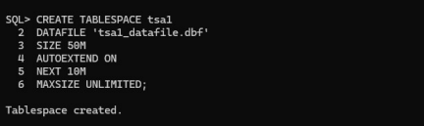CREATE CLUSTER trial_cluster (

trialno NUMBER(*,0)

)

HASHKEYS 150

HASH IS (trialno)

TABLESPACE users;

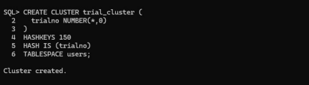

b. The hash cluster must have 150 unique hash values that are be generated by a user defined hash function.

CREATE OR REPLACE FUNCTION my_hash_function(trialno NUMBER)

RETURN NUMBER

IS

BEGIN

RETURN MOD(trialno, 150);

END;

7

/

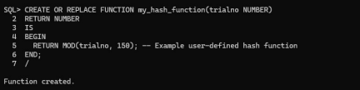

c. Store the cluster in tablespace tsa1.

CREATE TABLE trial (

trialno NUMBER(*,0),

description VARCHAR2(50)

)

CLUSTER trial_cluster (trialno);

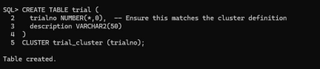

CONCLUSION:

In this practical, we successfully created and managed database clusters and users in Oracle SQL Plus, doing tasks such as creating users, granting privileges, and setting up data clusters,creating clusters, setting up indexes and hash clusters, inserting records into it from scott, altering it and dropping it as well.

8

9